Introduction
“The World Development Indicator Dataset is a compilation of relevant, high-quality, and internationally comparable statistics about global development and the fight against poverty.” The dataset, as currently updated, contained 1400 individual indicators going back to 1960, for sovereign states, some regional aggregations, and some dependencies. Many of the dataset’s indicators are unscaled to population size, and many are highly correlated, making this a perfect dataset for wrangling and applying machine learning algorithms to, given the impracticality of manually cleaning the data,
Owing to high amounts of missing data, I constrained the analysis to the 21st century, to whole country measures, to sovereign states only, and from there removed any indicators with >40% missingness. Before engaging in any machine learning, I used the package missForest to impute missing values after trimming. Given the high computational cost of these models, I simply used one imputation. In a workplace or research setting, I would conduct a sensitivity analysis showing multiple imputed data sets had similar results. Unsupervised learning revealed groupings of countries across space and time, recreating major economic trends in this period, including the rise of China to a peer of the United States, broad economic growth in the Global South and former Eastern Bloc, and Ukraine's turbulent post-2012 experience.
For an outcome of interest, I selected the percent of the population using the Internet, owing to it arguably being the biggest story of the last 25 years, and its bounded nature presenting a useful challenge. I fit four supervised learning models to the dataset. I fit two LASSO regularized linear regression models, finding that a logit-transformed model performed better for lower internet use rates, but a linear proportion model better for higher rates. The linear model predicts better overall, at the cost of 11% of predictions being outside the 0-100% range. A simple decision tree found that internet usage rates were largely a function of income and a country’s data gathering operations, albeit at the cost of worse performance than the LASSO. Finally, I fit a random forest, which had the best prediction performance, at the cost of being completely uninterpretable.

Data Cleaning and Unsupervised Learning:
Visualizations:
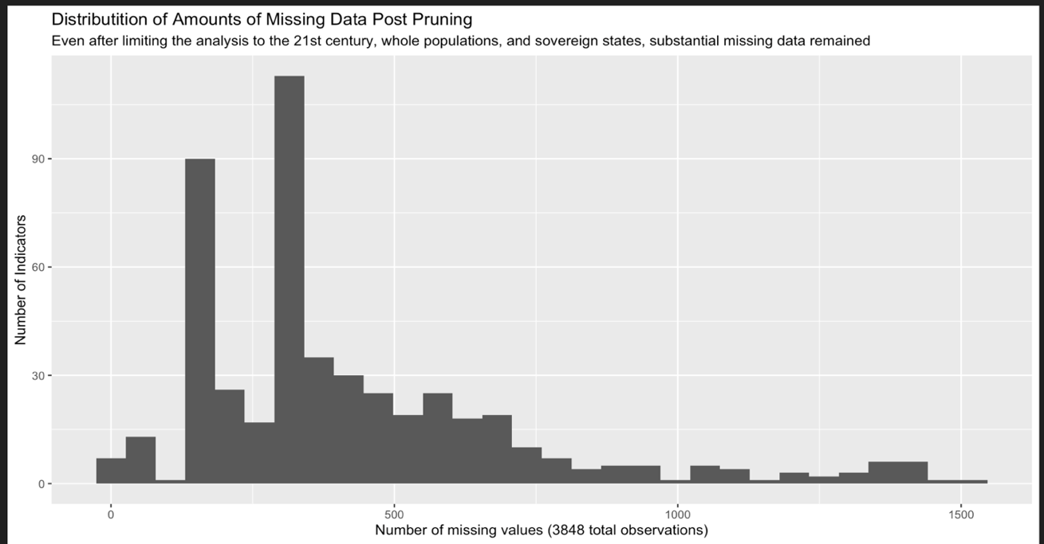

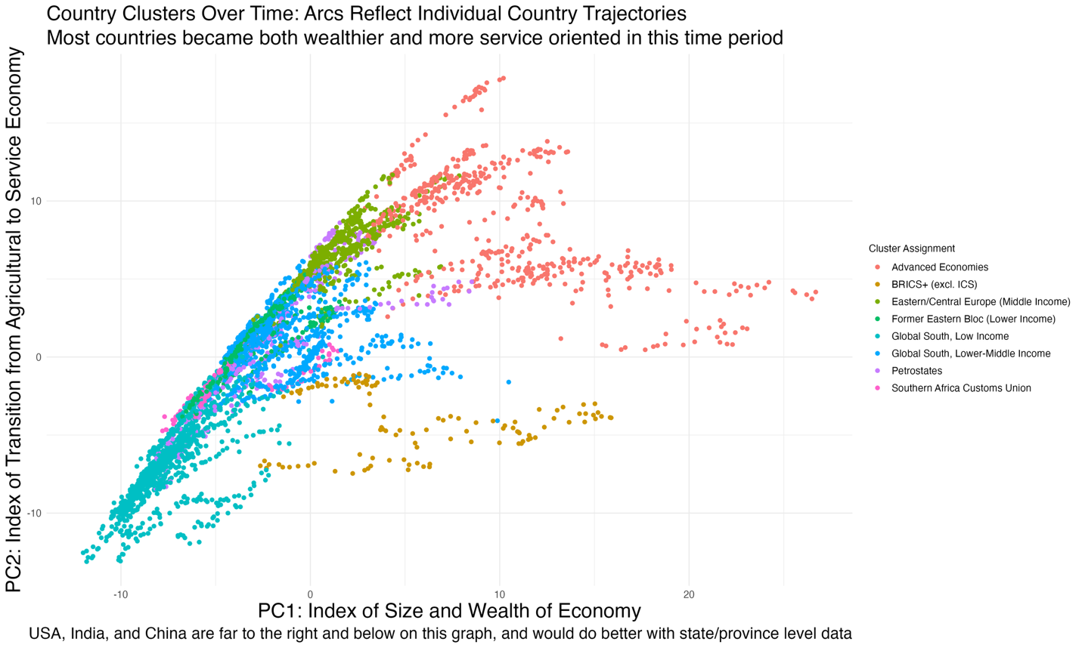

Summaries of Unsupervised Clustering Findings, Smallest to Largest:
Cluster numbering was done by the algorithm and is completely arbitrary. To avoid potential bias from missing data, I used the nipals algorithm for dimensionality reduction, which retained 80% of the original variation in the data while reducing the dimensionality from 500 indicators to 40 linear components. I used Ward’s method for hierarchical clustering, meaning any cluster can be split additionally as desired, much as one might want to split a marketing demographic into finer detail. The algorithm used did not have access to country names or year numbers, meaning that it created these aggregations purely from the indicators:
Cluster 8 was India for the entire time period, and China from 2000-2009. Cluster 6 was the United States for the entire time period, and China from 2010 on. This reflects China’s growing economy and wealth, making it more like the United States than India following the global financial crisis. Many indicators in the dataset were not scaled by population or economy size, so it is not surprising to find the three largest population countries together.
Cluster 9 was the Southern African Customs Union: South Africa, Botswana, Lesotho, Swaziland, and Namibia. The other 4 countries are economically quite reliant on South Africa, and have shared histories.
Cluster 10 was Brazil, Indonesia, Iran, and Russia for the entire time period, and Vietnam from 2011 onward. These are medium-large population and economy countries countries, commonly members of BRICS+. It does seem a heterogenous group, with Iran and Russia having older populations and economies more dependent on services and resources, while the other three have younger populations with economies with larger agricultural and manufacturing sectors.
Cluster 4 consists of Algeria, Angola, Azerbaijan, Bahrain, Brunei, the Republic of the Congo, Iraq, Kuwait, Libya, Oman, and Saudi Arabia for the entirety of the time period. The DRC visits the cluster in 2001 and Ukraine in 2024, both during major wars on their territory.
Cluster 1 is a group of former Soviet and Eastern Bloc countries marked by aging populations, though their economic fortunes have differed, with Latvia Lithuania relatively developed while Ukraine and Moldova remain the poorest countries in Europe. The cluster is Albania, Armenia, Georgia, Kazakhstan, Kyrgyzstan, Mongolia, Moldova, Tajikistan, and Uzbekistan for almost all of the period. Belarus, Bosnia, Bulgarian, Latvia, Lithuania, Northern Macedonia, and Romania permanently leave the cluster in the time period of 2008-2012, a time when their growing economies weathered the global financial crisis better than the rich world. Ukraine dips in and out of the cluster.
Cluster 7 is interesting. First, in the cluster for the entire time frame are the Bahamas, Croatia, Cyprus, Czechia, Estonia, Greece Hungary, Israel, Malta, New Zealand, Poland, Portugal, Slovakia, and Slovenia. Some members of Cluster 1 that left during the financial crisis mostly joined this cluster: Belarus, Latvia, Lithuania, and Romania. Ireland enters the cluster in 2005 and leaves in 2014, on a pattern in its own. Ukraine is in the cluster in certain years, including the Maidan Revolution. The cluster then is primarily Eastern/Central/"Outer" Europe, and a few countries that share similar traits.
What is particularly interesting is that a number of middle income countries primarily in central/South America or near Iberia join cluster 7 in just 2020, reflecting their experience of the first pandemic year: Bolivia, Cabo Verde, Columbia, the Dominican Republic, Ecuador, Jamaica, Mauritius, Morrocco, Panama, Peru, and Tunisia.
Cluster 5 is the rich world. It consists of, for the entire time frame: Austria, Australia, Belgium, Canada, Denmark, Finland, France, Germany, Iceland, Italy, Japan, South Korea, Luxembourg, the Netherlands, Norway, Singapore, Spain, Sweden, Switzerland and the UK. The only temporary member is Ireland, which spent its time not in cluster 7 here.
Cluster 2 and 3 were by far the largest clusters, so I attempted additional splits, which split each cluster by time, not country.
Cluster 2 was low-middle income countries in Latin America, North Africa, and Southeast Asia. Splitting the cluster divided it by time, with 2.1 being before 2011-2016 depending on country, and 2.2 after.
Cluster 3 was low-income countries in Sub-Saharan Africa and South Asia. Splitting this cluster had similar results to 2. Interestingly, Ukraine was assigned to this cluster in 2022 and 2023, reflecting the economic crisis occurring during the escalation of the war.
Ukraine was, in my opinion, the most interesting country in this period. It spends most of its time in cluster 1, with countries with similar economic histories, on the poorer side. It joins cluster 7 at certain points, with the wealthier former Eastern Bloc countries, including during the immediate aftermath of the Maidan Revolution. The damage its society suffered during the worse of the war pushed it into the poorest group, recovering in 2024 to join other middle-income countries, I don't think any other country traveled through more than 2 clusters.
Supervised Learning: 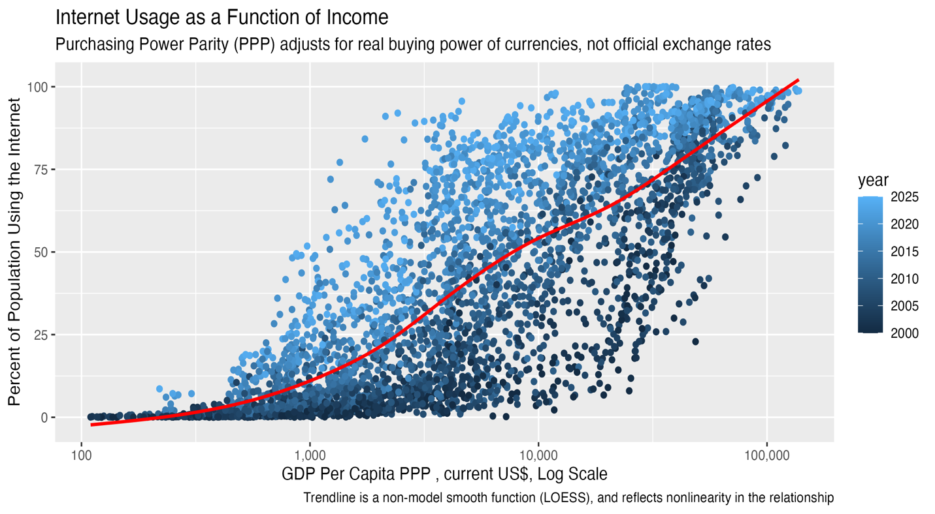
I used four models to predict internet usage using the other 500 indicators preserved in the dataset. The LASSOs are fully parametric, assuming a certain relationship between the predictors and the outcome, while the decision tree and random forest are nonparametric, allowing the model to make choices as optimal.
For each model, the software reports three measures of accuracy: root mean squared error (RMSE), R-square(R2), and mean absolute error (MAE). RMSE and MAE are different measures of the average inaccuracy of the model and can be thought of as the average number of percentage points the model is off. RMSE is more computationally useful and penalizes large errors disproportionately, but MAE is more intuitive. R2 is the percent of variation in the original dataset explained by the model. By these three measures, there is a clear order of accuracy, from worst to best, the logit LASSO, the decision tree, the linear LASSO, then the random forest.

But there is more to prediction than overall accuracy. First, let’s consider the logit LASSO. It overall does terribly, but it shines at very low levels of internet use:
MAE:
Usage Range | Linear | Logit | Tree | Forest
0-10% | 6.7 | 1.9 | 7.4 | 1.5
10-30% | 8.4 | 6.9 | 11.9 | 2.0
30-50% | 6.8 | 17.0 | 14.2 | 2.0
50-70% | 7.2 | 29.7 | 14.8 | 2.0
70-90% | 7.9 | 41.9 | 9.2 | 2.2
90-100% | 8.4 | 52.0 | 11.5 | 2.4
The logit applies a nonlinear transformation to the data, such that small differences in usage at very low levels matter more to the model than at labels closer to 50%. So when internet usage was lower than 30%, it performed better than the linear model or the tree, and when lower than 10%, almost as well as the forest. I fit this model because the linear model knows no bounds, and as such predicts 9% of observations to have usage rates lower than 0%, and 3% of observations greater than 100%, which is nonsensical. The logit model can never make such errors, only predict values extremely close to 0 or 100%. That all said, less than 1% of the observations in the 2020s had internet usage less than 10%, so the logit model is more useful for predicting historical data.
Moving onto the decision tree, it is by far the simplest model.
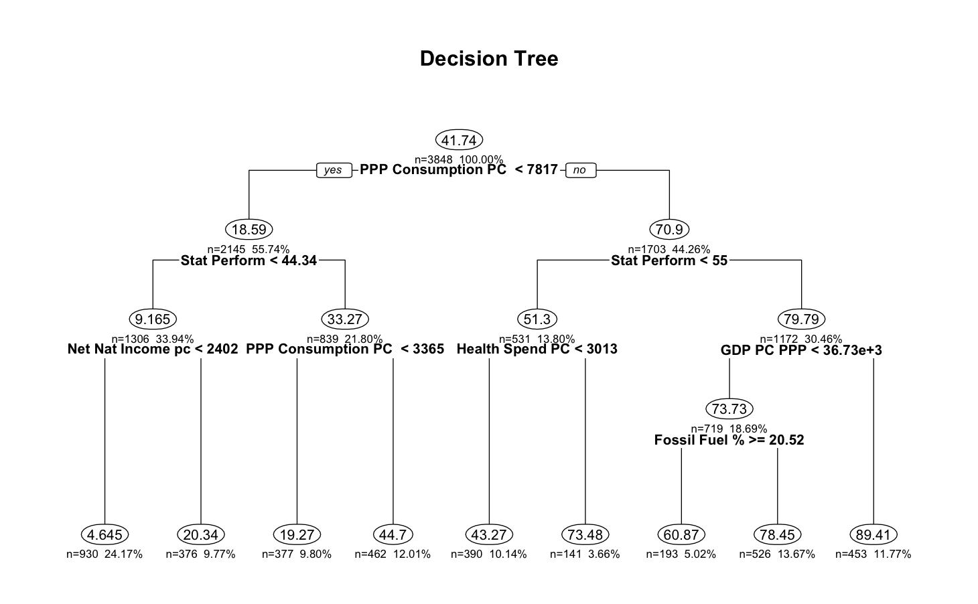
This is the decision tree. Yep, that’s it. It predicts the highest internet rates (85%) for those with GDP per capita in purchasing power parity (PPP, a currency exchange adjusted measure of income), greater than $21,000, an import value index greater than 88, and a statistical performance indicator index greater than 65, and predicts 12% of observations have 85% use.
It predicts the lowest internet rates (4.3%) for those with adjusted net national income per capita less than $1603, and a GDP deflator index less than 99, indicating an economy valued less in nominal terms than real terms, or in other words, a shrinking economy or one with a currency increasing in value.
Finally, there is the matter of the random forest, an ensemble of 500 decision trees that returns the averaged response. It is by far the most computationally intensive model and cannot be interpreted beyond overall variable importance, nor visualized. Tuning involves selecting the number of predictors considered at each split (mtry), with larger values generally improving accuracy at the cost of increased overfitting risk. All models used 10-fold cross-validation to guard against overfitting, with the random forest's ensemble nature providing additional protection. The fit statistics reported reflect a parsimonious specification using just four predictors: infant mortality, universal healthcare infectious disease coverage, statistical performance index, and GNI per capita PPP. Increasing the predictor count to eight reduced MAE from 5.05 to 4.61, a modest gain that, in my assessment, does not justify doubling model complex.
The most important predictors varied strikingly across models. For the linear LASSO, primary school gender parity emerged as the top predictor; for the logit LASSO, ores and metal imports as a share of total imports; for the decision tree, GNI per capita PPP; and for the random forest, infant mortality. This divergence, all using identical data and outcome, underscores a fundamental point: importance is model-dependent. None of these findings imply causality; they merely indicate predictive utility.
The primary limitation of this analysis was the handling of missing data. The data used in machine learning was a fraction of the overall dataset that had the least missing data. Even then, substantial imputation was necessary, and the imputation algorithm used did not use the longitudinal nature of the data, treating all observations as independent, as if country label and year were any other variable. A more sophisticated analysis would take a more curated subsection of the data, ideally making up for pruning with thoughtful selection of years, countries, and variables, and using a longitudinal data algorithm.
If forced to select a single model for real-world prediction, I would choose the linear LASSO. It best balances interpretability, as coefficients are directly readable, with predictive performance. That said, model selection should always be guided by the specific use case, as prediction for its own sake is rarely the goal. Understanding why a prediction holds often matters more than the prediction itself.

Data Source:
World Bank. (2024). World Development Indicators. Washington, DC: World Bank. https://datatopics.worldbank.org/world-development-indicators/
R packages used:
- Corporation M, Weston S (2022). _doParallel: Foreach Parallel Adaptor for the 'parallel' Package_. doi:10.32614/CRAN.package.doParallel <https://doi.org/10.32614/CRAN.package.doParallel>, R package version 1.0.17, <https://CRAN.R-project.org/package=doParallel>.
- Kassambara A, Mundt F (2020). _factoextra: Extract and Visualize the Results of Multivariate Data Analyses_. doi:10.32614/CRAN.package.factoextra <https://doi.org/10.32614/CRAN.package.factoextra>, R package version 1.0.7, <https://CRAN.R-project.org/package=factoextra>.
- Kuhn, Max (2008). “Building Predictive Models in R Using the caret Package.” _Journal of Statistical Software_, *28*(5), 1–26. doi:10.18637/jss.v028.i05 <https://doi.org/10.18637/jss.v028.i05>, <https://www.jstatsoft.org/index.php/jss/article/view/v028i05>.
- Lindeløv J (2024). _job: Run Code as an RStudio Job - Free Your Console_. doi:10.32614/CRAN.package.job <https://doi.org/10.32614/CRAN.package.job>, R package version 0.3.1, <https://CRAN.R-project.org/package=job>.
- Makowski D, Lüdecke D, Patil I, Thériault R, Ben-Shachar M, Wiernik B (2023). “Automated Results Reporting as a Practical Tool to Improve Reproducibility and Methodological Best Practices Adoption.” _CRAN_. doi:10.32614/CRAN.package.report <https://doi.org/10.32614/CRAN.package.report>, <https://easystats.github.io/report/>.
- Milborrow S (2026). _rpart.plot: Plot 'rpart' Models: An Enhanced Version of 'plot.rpart'_. doi:10.32614/CRAN.package.rpart.plot <https://doi.org/10.32614/CRAN.package.rpart.plot>, R package version 3.1.4, <https://CRAN.R-project.org/package=rpart.plot>.
- Müller K (2025). _here: A Simpler Way to Find Your Files_. doi:10.32614/CRAN.package.here <https://doi.org/10.32614/CRAN.package.here>, R package version 1.0.2, <https://CRAN.R-project.org/package=here>.
- Müller K, Wickham H (2026). _tibble: Simple Data Frames_. doi:10.32614/CRAN.package.tibble <https://doi.org/10.32614/CRAN.package.tibble>, R package version 3.3.1, <https://CRAN.R-project.org/package=tibble>.
- R Core Team (2025). _R: A Language and Environment for Statistical Computing_. R Foundation for Statistical Computing, Vienna, Austria. <https://www.R-project.org/>.
- Stacklies W, Redestig H, Scholz M, Walther D, Selbig J (2007). “pcaMethods - a Bioconductor package providing PCA methods for incomplete data.” _Bioinformatics_, *23*, 1164-1167.
- Stekhoven DJ (2025). _missForest: Nonparametric Missing Value Imputation using Random Forest_. R package version 1.6.1. Stekhoven DJ, Bühlmann P (2012). “MissForest: nonparametric missing value imputation for mixed-type data.” _Bioinformatics_, *28*(1), 112-118. doi:10.1093/bioinformatics/btr597 <https://doi.org/10.1093/bioinformatics/btr597>.
- Therneau T, Atkinson B (2025). _rpart: Recursive Partitioning and Regression Trees_. doi:10.32614/CRAN.package.rpart <https://doi.org/10.32614/CRAN.package.rpart>, R package version 4.1.24, <https://CRAN.R-project.org/package=rpart>.
- Wei T, Simko V (2024). _R package 'corrplot': Visualization of a Correlation Matrix_. (Version 0.95), <https://github.com/taiyun/corrplot>.
- Wickham H (2016). _ggplot2: Elegant Graphics for Data Analysis_. Springer-Verlag New York. ISBN 978-3-319-24277-4, <https://ggplot2.tidyverse.org>.
- Wickham H, Averick M, Bryan J, Chang W, McGowan LD, François R, Grolemund G, Hayes A, Henry L, Hester J, Kuhn M, Pedersen TL, Miller E, Bache SM, Müller K, Ooms J, Robinson D, Seidel DP, Spinu V, Takahashi K, Vaughan D, Wilke C, Woo K, Yutani H (2019). “Welcome to the tidyverse.” _Journal of Open Source Software_, *4*(43), 1686. doi:10.21105/joss.01686 <https://doi.org/10.21105/joss.01686>.
- Wickham H, François R, Henry L, Müller K, Vaughan D (2026). _dplyr: A Grammar of Data Manipulation_. doi:10.32614/CRAN.package.dplyr <https://doi.org/10.32614/CRAN.package.dplyr>, R package version 1.2.1, <https://CRAN.R-project.org/package=dplyr>.
- Wickham H, Henry L (2026). _purrr: Functional Programming Tools_. doi:10.32614/CRAN.package.purrr <https://doi.org/10.32614/CRAN.package.purrr>, R package version 1.2.2, <https://CRAN.R-project.org/package=purrr>.
- Wickham H, Hester J, Bryan J (2026). _readr: Read Rectangular Text Data_. doi:10.32614/CRAN.package.readr <https://doi.org/10.32614/CRAN.package.readr>, R package version 2.2.0, <https://CRAN.R-project.org/package=readr>.
- Wickham H, Vaughan D, Girlich M (2025). _tidyr: Tidy Messy Data_. doi:10.32614/CRAN.package.tidyr <https://doi.org/10.32614/CRAN.package.tidyr>, R package version 1.3.2, <https://CRAN.R-project.org/package=tidyr>.
- Xie Y (2025). _knitr: A General-Purpose Package for Dynamic Report Generation in R_. R package version 1.51, <https://yihui.org/knitr/>. Xie Y (2015). _Dynamic Documents with R and knitr_, 2nd edition. Chapman and Hall/CRC, Boca Raton, Florida. ISBN 978-1498716963, <https://yihui.org/knitr/>. Xie Y (2014). “knitr: A Comprehensive Tool for Reproducible Research in R.” In Stodden V, Leisch F, Peng RD (eds.), _Implementing Reproducible Computational Research_. Chapman and Hall/CRC. ISBN 978-1466561595.

